**we will know, how we can get the value filled in input box**

**we use state ↓**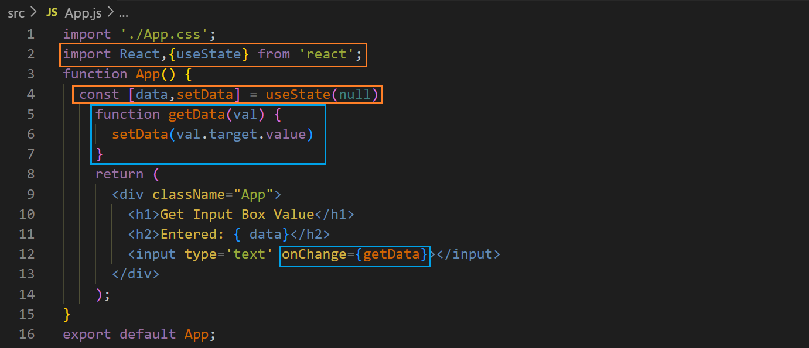

**output ↓**